**Project Proposal**

**<Database Application>**

**--- Stock market simulator**

Submitted in partial fulfillment of the Course CS542 - Database Management Systems

Students Involved in this project:

Chengjiao Yang

Jian Qiao

Zheng Yang

**Revision History**

|  |  |  |  |
| --- | --- | --- | --- |
| Data | Version | Description | Author |
| 10/15/2014 | <1.0> | create document | Jian Qiao |
| 10/15/2014 | <1.0> | document structure | Chengjiao Yang |

Preface

1. Introduction 3

1.1 Purpose 3

1.2 Scope 3

1.3 Definitions, Acronyms and Abbreviations 3

1.4 Overview 3

2. Project Overview 3

2.1 Project purpose 3

2.2 Domain requirements, queries and interfaces 3

2.3 Project deliverables 4

3. Architecture 4

3.1 Environment and tools 4

3.2 Integrated architecture 4

3.3 ER model 5

4. Management Process 5

4.1 Phase Plan 1)Prepare and Research phase: 5

4.2 Project Schedule 6

4.3 Project Resourcing: Training Plan 7

4.4 Roles and Responsibilities 7

# 1. Introduction

## 1.1 Purpose

The Information Gathering step is outlined in this project proposal which will be necessary to carry out the development process.

## 1.2 Scope

Scope of this project is based on the database management system course requirements, establish a stock trading simulation system, full use of the database design knowledge plus the program to achieve application logic.

## 1.3 Definitions, Acronyms and Abbreviations

Java Database connectivity (JDBC)

Entity-relationship diagram (ERD)

Stock market simulation (SMS)

## 1.4 Overview

The following section will be focusing on the project introduction, project architecture, database design, ER Model, Object Design, Implementation, mile stone, task distribution and test Plan.

# 2. Project Overview

## 2.1 Project purpose

The purpose of **stock market simulator** is that attempts to reproduce or duplicate some or all features of a live stock market on a computer so that a player may practice trading stocks without financial risk. Our system is used for educational purposes to teach potential stock traders and future stock brokers how to trade stocks. It can also be used for entertainment purposes and to engage in fantasy trading competitions.

## 2.2 Domain requirements, queries and interfaces

**Domain requirement:**

market（marketIndex,Variation range,Overall capital）

company（Cid,price,Price/share,Overall shares,Variation range, Market valuation）

Investors（userID,password,Assets,Amount of shares）

order（userID,Cid,shares）

transactionLog（TID,userID,Cid,time,price）

**Queries:**

Our system supports **select, delete, insert and update** queries to have data investors needed.

For example, system will execute queries **select change from company** to show the changes if investors want to view stock movements. System will execute **update Investors set Assets=Assets-n where userID=(one investor's ID)** if this investor bought or sold some stock, etc. Overall, **select, delete, insert and update** queries is going to be executed whenever any data changing or data needed.

**Interfaces:**

Our system provide following interfaces:

buy-stock button: Investors can buy stock via clicking buy-stock button.

sell-stock button: Investors can sell stock via clicking buy-stock button.

review-transaction-history button: Investors are able to review his/her transaction history via clicking review-transaction-history button.

refresh-button: refresh-button is used for refreshing screen to present investors with the most updated data.

## 2.3 Project deliverables

|  |  |
| --- | --- |
| Deliverable | Date |
| Project proposal | 10/16 |
| Project-progress report | 11/13 |
| Final project, final report, presentation PPT, user manual | 12/15 |

# 3. Architecture

## 3.1 Environment and tools

Program language: JAVA 1.6

Operate System: Windows 7

Database: MySQL 5.7

JDBC: 5.1.33

Eclipse: Luna Release (4.4.0)

## 3.2 Integrated architecture

We are using JAVA language to develop applications, JAVA itself does not directly connect to the database, and it interact with the database via JDBC. JDBC technology is an API for the Java programming language that defines how a client may access a database. It provides methods for querying and updating data in a database. JDBC is oriented towards relational databases. Thus, JAVA treat the database as a model, an object to process, then we can focus on the business logic program.

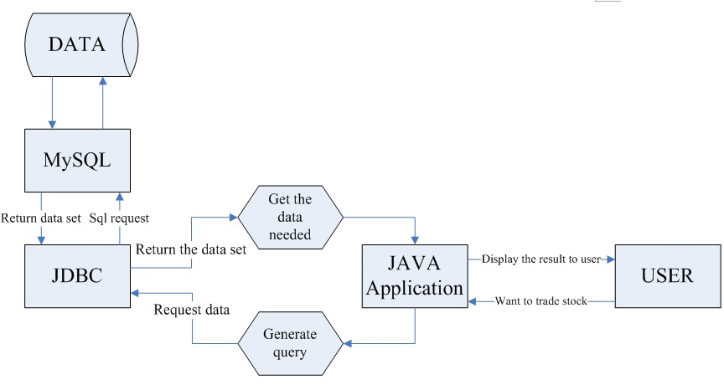

3.3 ER model

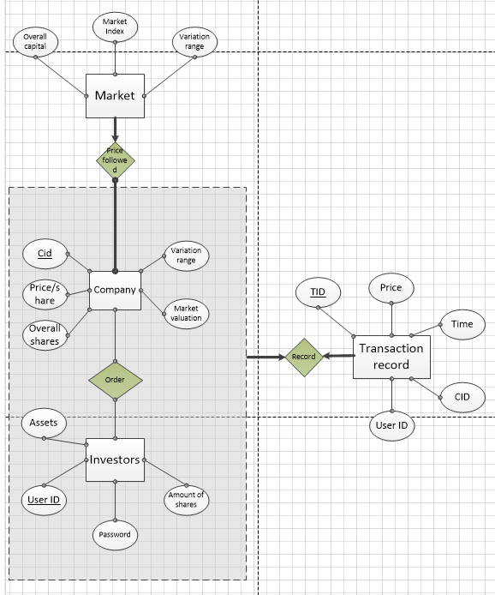

# 4. Management Process

## 4.1 Phase Plan

**1) Prepare and Research phase:**

Domain knowledge reserves, reading and studying the relevant technical documentation and knowledge, analysis and design application framework and write the relevant documents, communication and discussions, deeply understanding of the technical knowledge required.

**2) Progress Report phase:**

Have conducted all necessary background work including establishing a bibliography, reading relevant papers, completed setup of the development tools and environment, and resolving any design issues of your proposed system.

**3) Coding phase:**

Establish and improve the database, use java to code the core application functionality, synchronize

doing the unit testing, design and improve the user interface, and develop the extra functions if needed.

**4) Final phase:**

Complete the whole project, Optimize database performance and query performance, doing the integration test and bug fix, write the final report, prepare the final presentation.

## 4.2 Project Schedule

|  |  |
| --- | --- |
| WEEK | SCHEDULE |
| Week1 (10/16-10/23) | * Discuss and design the database model * Discuss and design the application architecture * Make plan, mile stone |
| Week2 (10/24-10/30) | * Research domain knowledge * Background material research |
| Week3 (10/31-11/06) | * Build up the program framework * Build up the MySQL database and constrains, relations |
| Week4 (11/07-11/13) | * Complete program framework coding * Design the user interface * Complete the project-progress report * Unit test |
| Week5 (11/14-11/20) | * Integrate the program framework and database * Program the application logic * Unit test |
| Week6 (11/21-11/27) | * Develop the core application work flow * Perfect the database * Unit test |
| Week7 (11/28-12/04) | * Continue the core application logic developing * Auxiliary function develop * Perfect the user interface * Unit test |
| Week8 (12/05-12/11) | * Complete the application * Integration test |
| Week9 (12/11-12/15) | * Complete the project final report * Prepare the test data * Write PPT and prepare the presentation |

## 4.3 Project Resourcing

This part is the knowledge we're going to research and prepare, as well as the learning curve and detail plan.

**Background material:**

1) Stock, <http://en.wikipedia.org/wiki/Stock>

2) Stocks and bonds,

<https://www.khanacademy.org/economics-finance-domain/core-finance/stock-and-bonds>

3) W3C school, <http://www.w3schools.com>

4) Database management system book

5) JAVA World, <http://www.javaworld.com/article/2077188/core-java/introduction-to-the-awt.html>

6) AWT guide, [http://www.tutorialspoint.com/awt/](http://www.javaworld.com/article/2077188/core-java/introduction-to-the-awt.html)

7) MySQL guide, [http://dev.mysql.com/doc/mysqldoc-guide/en](http://www.javaworld.com/article/2077188/core-java/introduction-to-the-awt.html)

**Traning plan:**

|  |  |  |
| --- | --- | --- |
| Name | Training needed | Estimated Time |
| Chengjiao Yang | Java, AWT | 11.13.2014 |
| Jian Qiao | Java, MySQL | 11.11.2014 |
| Zheng Yang | Java, MySQL, AWT | 11.14.2014 |

## 4.4 Roles and Responsibilities

|  |  |  |
| --- | --- | --- |
| Role | Responsible | Name |
| Captain | Push the whole project and organize the group meeting every week (3pm Monday). | Yang Chengjiao |
| Presenter | Write and Present the final PPT. | Zheng Yang |
| Document organizer | Take charge of composing, organizing and modifying documents. | Qiao Jian |
| Database designer | Design of MySQL database and ER chart and related document content. | Zheng Yang |
| Main program developer | Determine and develop system frame and related document content, chief developer. | Yang Chengjiao, Qiao Jian |
| Program Assistant | Assistant in related development and documents. | Zheng Yang |